Experiment1.4

Student Name: Himanshu UID: 20BCS7944
Branch: CSE Section: 905/A
Semester: 6 Date of Performance: 22/03/2023
Subject Name: Data Mining Lab Subject Code: 20CSP-376

1) Aim:

Demonstration of FP Growth algorithm on supermarket.

2) Objective:

Overcoming the disadvantages of apriori algorithm using fp-growth algorithm.

3) Code:

library(arules)
setwd("/home/heefe/Documents/DMClassWork/")
data("Mushroom")
fprules <- fim4r(Mushroom, method = "fpgrowth", target = "rules", supp = 70, conf = 60)
fprules
inspect(fprules[1:5])
x <- as(fprules,"data.frame")
write.csv(x, file = "FP.csv", row.names = FALSE)

4) Output:

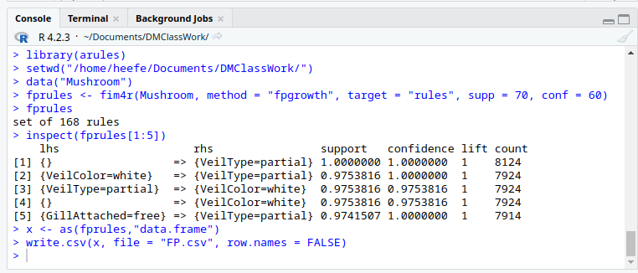
CSV file created-

